BID BOX

TRADE FINANCE

VERSION 1.0.0

TEST EVIDENCE

Below is the test evidence of the failed test cases from the previous review.
- Individual Signup error
The error above was occurring once you click submit during the sign up. The reason this was happening was because the ID number provided by the user could not be verified through the integrated population registration system (IPRS). This has been resolved by redirecting the user to another page and also sending an email to alert the user to check the details provided. See below
We will use an invalid identification number.
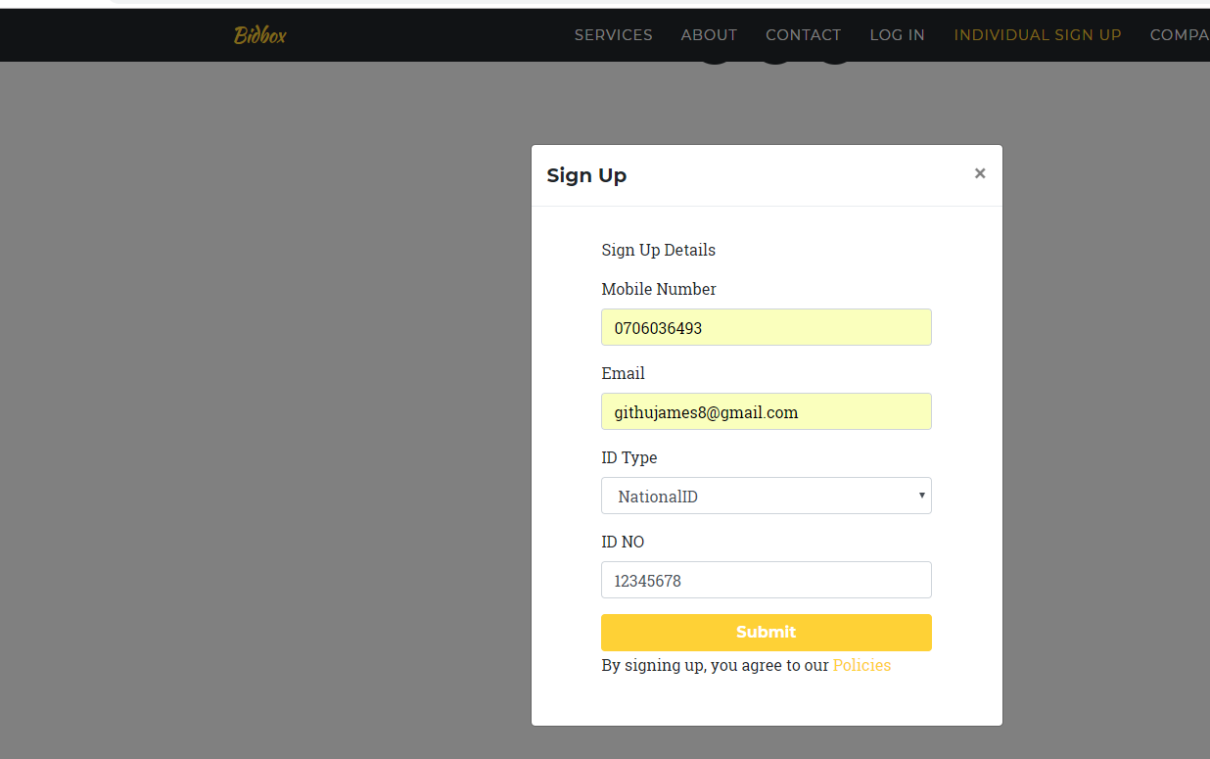
When we click submit button, an email is sent to the email address provided and also redirected to the unsuccessful registration page.

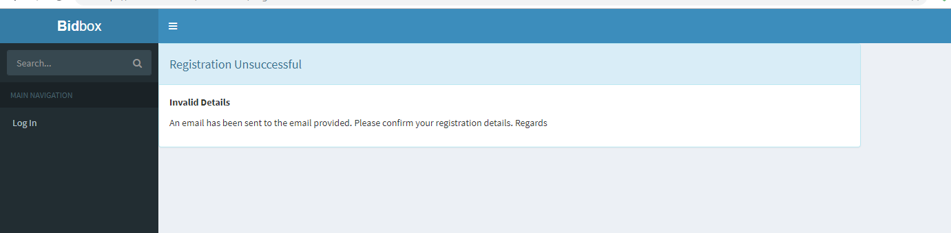
Email
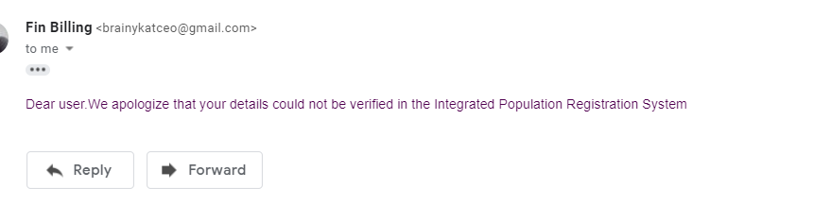
- Company sign up error
You were redirected to the view below in case a user clicks submit without providing the details.
This has been resolved by validating all the input fields. The registration won’t go through successfully if all the fields are not filled. See below.
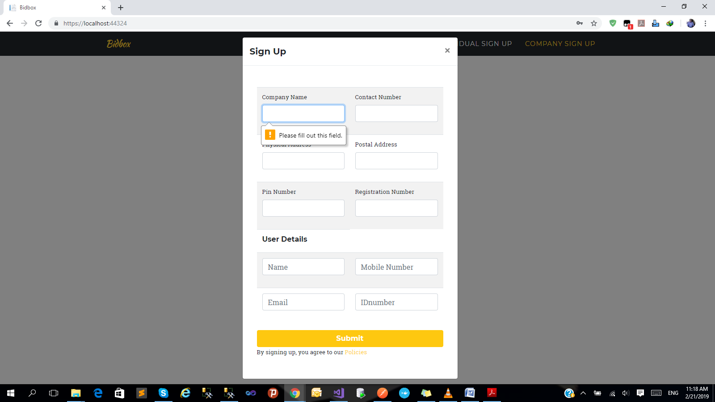
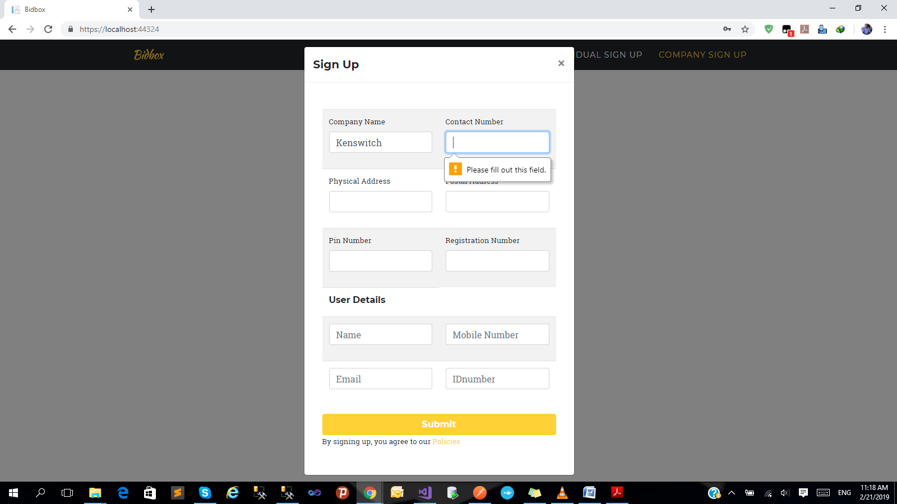
- BidBox logo
This error was received when the logo was clicked.

To resolve this, once the logo has been clicked, you will be redirected to the home page.
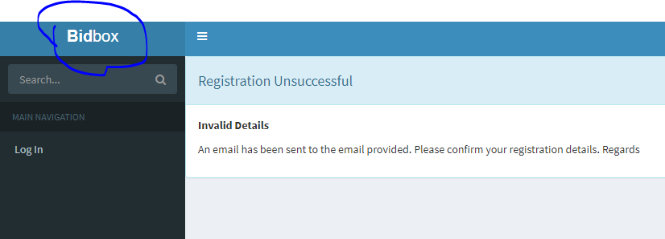

- Bank set up
Error – The bank code accepts characters.
We have made an enhancement on this that only numbers will be accepted as the input on the bank code field.
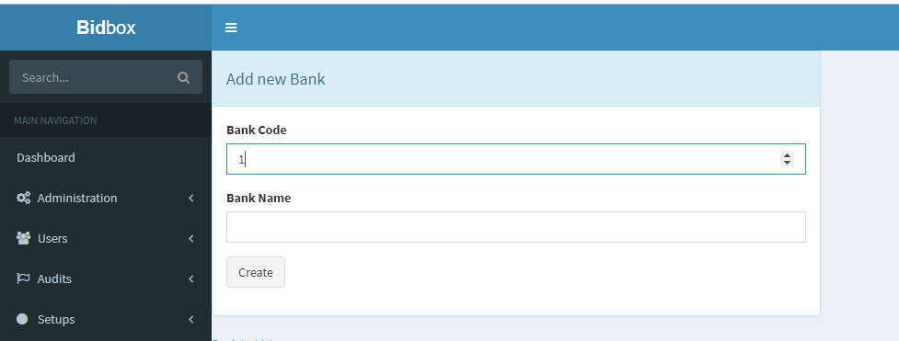
Once the back to list link was clicked, there was an error of access rights.
The right roles have been assigned to the respective users to allow them to view the list of banks.
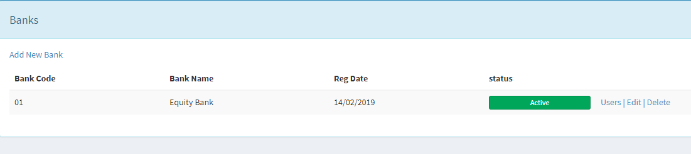
- Setups
Editing ID-Types, Marital Status, Suffixes and also nationalities.
You can now edit the above set ups as seen below.
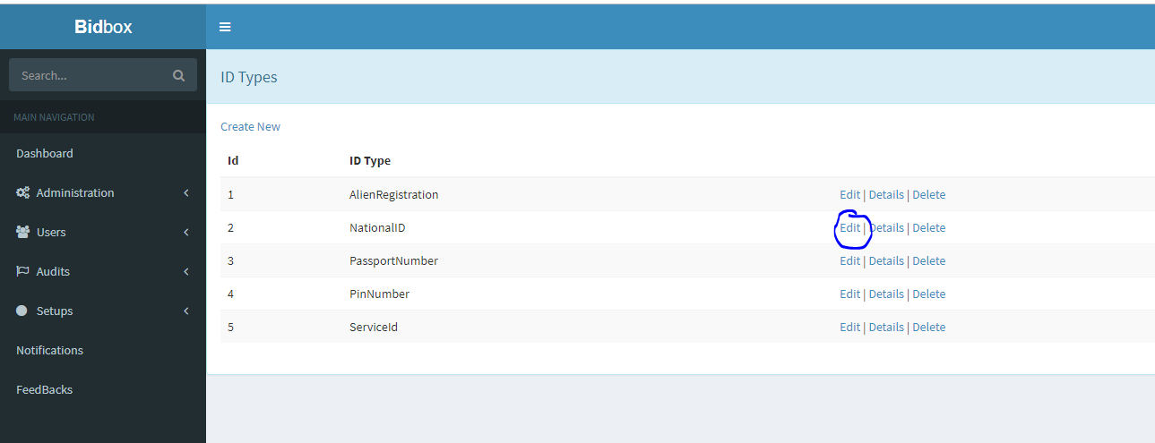
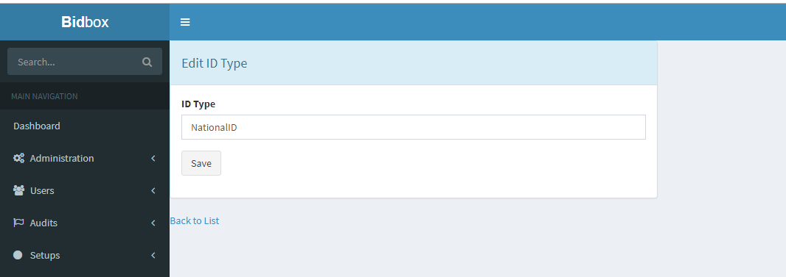
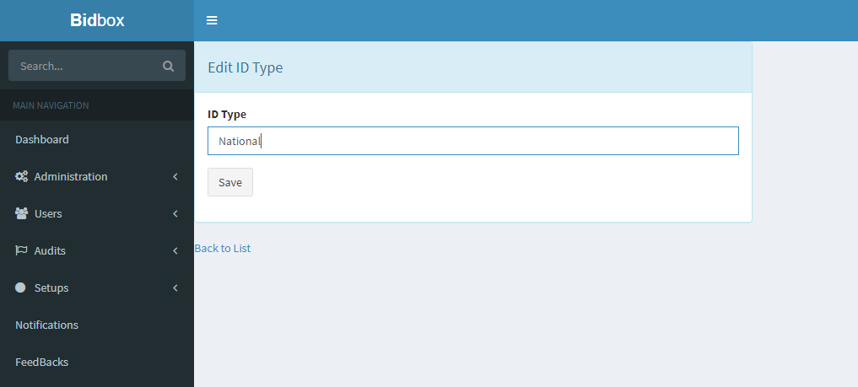
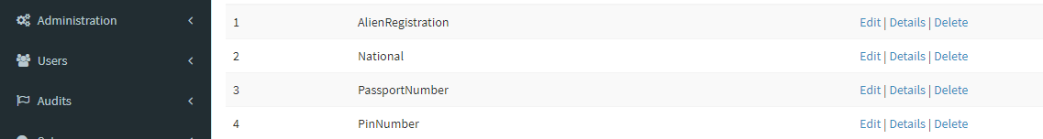

Marital status.
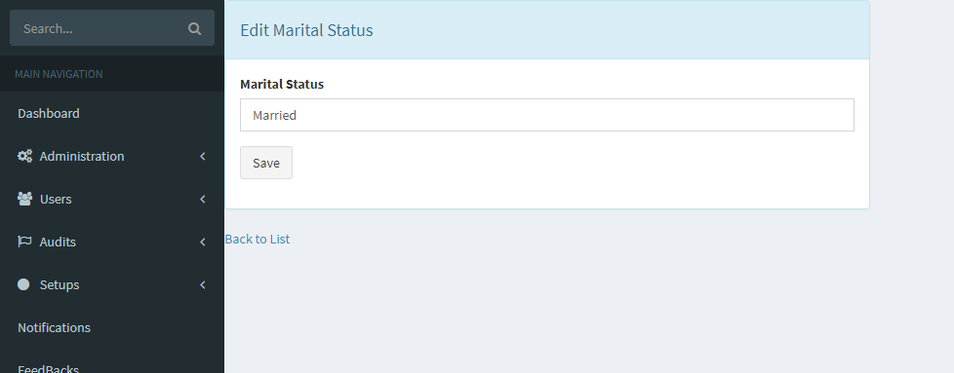

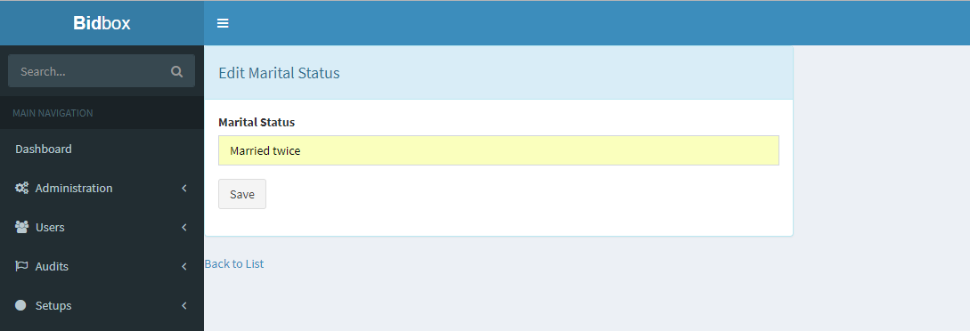
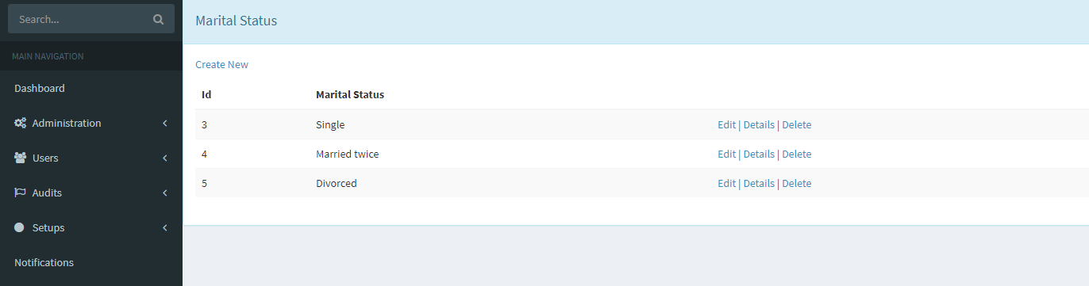
- Bank User Approval
When you click details under bank applications, the error below was being received.
The reason was due to a validation that had been added limiting the user to view the details in-case there were no CRB details available for that particular applicant
This has been enhanced to allow the user to view the details as shown below.
